**Assessment 1**

**Problem definition statement:**

Simple banking application which will include functionality to login, check balance, make deposits and withdrawals. The user should be able to transfer fund between two accounts. When all transactions are completed the user should be able to logout.

**Class Diagram:**

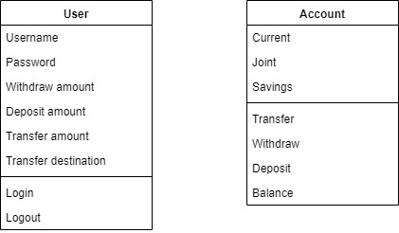

**Data dictionary:**

|  |  |
| --- | --- |
| **Name** | **Data Type** |
| username | String |
| password | String |
| currentBalance | Integer |
| jointBalance | Integer |
| savingsBalance | Integer |
| withdrawlAmount | Short |
| depositAmount | Short |
| transferAmount | Short |
| transferDestination | Byte |
| Logout | Boolean |